  - C++ No-SQL Database Web Framework for Cloud-based Websites

Outline
- What is a web framework
Outline
- Prerequisites
- Web frameworks
- Types of websites
- Architecture
- Sample application
- Code walkthrough
- Summary

Prerequisites
- C++: classes, templates, STL
- Javascript: classes, jQuery
- Networks: HTTP, sockets, REST, get, post
- Databases: key-index DBs, DB APIs
- Linux: command line, bash, g++, cmake
- Data access : DTO, DAO, JSON, serialization/deserialization
- Docker: containers, dockerfiles
- Cloud servers: Google cloud, AWS

What is a Web Framework
- Supports dynamic websites
- Increases developer productivity
  - Provide built-in code to handle tasks
  - Shortens time to create a web application
- Enforces specific coding patterns
  - Simplifies network and database access
  - Allows consistency and understandability
  - Increases maintainability

Other C++ Web Frameworks
- Other web frameworks
  - Oat++ (oatpp.io)
  - Drogon (drogon.org)
  - POCO (pocoproject.org)
  - TreeFrog (www.treefrogframework.org)
  - Pistache (pistache.io)
- Why use this framework
  - Is simpler
  - Good starter or learner web framework

Why use this framework
- Written in C++ and uses a No-SQL database
  - Faster than interpreted languages or RDMS
  - Increases user responsiveness
  - Reduces cloud server CPU and storage costs
- Simpler to program
  - Fewer components for developers to manage
- More convenient system administration
  - Easier to deploy to the cloud
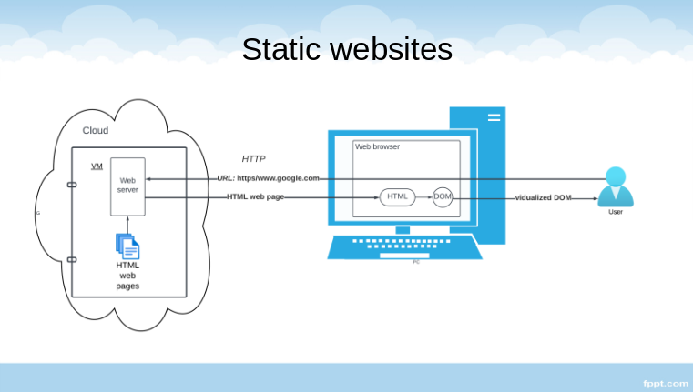

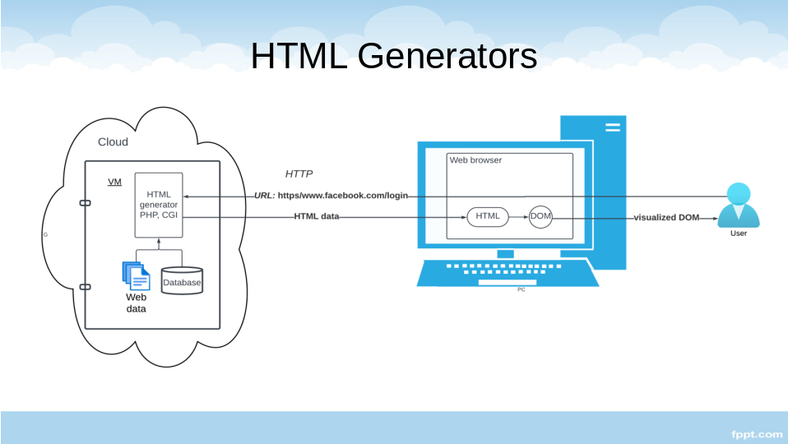

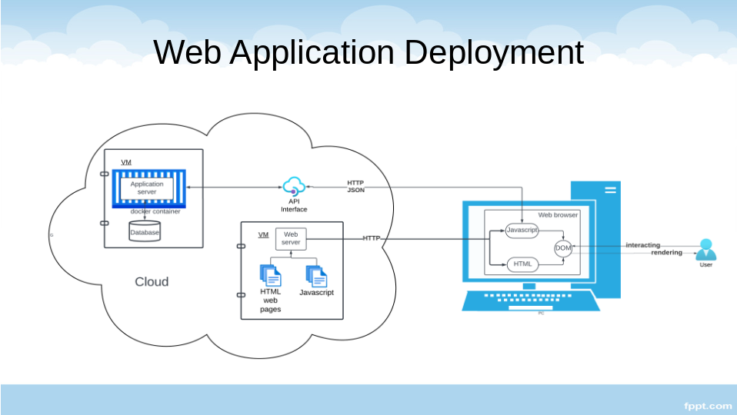

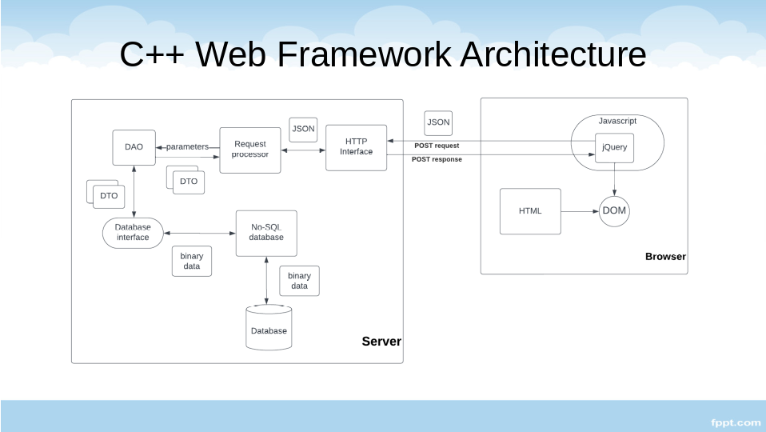

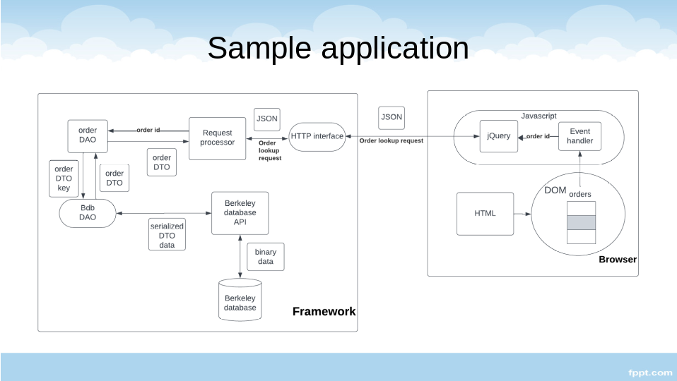

Code walkthrough
- Main program socket interface:
  - Bdb_inet_socket_server/Bdb_inet_socket_client
- JSON Request handler: Dconf_request_handler
- Order request handler: Dconf_order_request_handler
- Order lookup: Order_DAO, Order_DTO
- Database interface: Bdb_DAO
- Berkeley DB access: Bdb_dbp, Bdb_dbt

Conclusions
- The C++ Web Framework supports dynamic websites
- Consists of a web server, application server, and browser
- Developer tasks:
  - Design data interface
  - Define request processor
  - Write HTML, Javascript, jQuery for browser
  - Deploy web and application server to cloud environment
- Framework supplies network/DB/data interfaces

